# Chapter 3 Notes Exercises

## 3-3 Appending Products from a folder

1. Importing (each file in its own excel file)
   1. Data > Get Data > From Workbook > From Folder
   2. Combine and Transform
   3. Select sheet 1

## 3-4 – Appending Worksheets

1. Importing (One excel sheet with multiple tabs)
   1. Data > Get Data > From Workbook > From Folder > C03E04 – Year per Worksheet
   2. Select the Folder then click Transform Data
2. Remove the column’s Item, Kind and Hidden
3. Expand the Data column
   1. Uncheckmark the use orginal column name as prefix
4. Steps
   1. Home > Use First Row as Headers
   2. Click the dropdown beside Name and filter out the “Name”
   3. Rename the First column to Release Year
   4. Close and Load to Table
5. Open the Original Excel File containing the content
   1. Add a new worksheet called 2018 at the end and make sure to save
   2. Then go back to your other worksheet you were working on
6. Right click the query and refresh
   1. You should see the new 2018 added to the end of the list
7. Open up the original Excel File containing the content
   1. Add a new worksheet called 2013 at the beginning and make sure to save
   2. Then go back to your other worksheet you were working on and you will see it does not work anymore.
8. Right click the Query in the file you are working on and refresh
   1. You will see an error pop up
   2. Open the Query
   3. Click on the Changed Type in the queries then change the “2015” to “2014”
   4. We need to make this dynamic though so we need to add this code to the Changed Type: (Click on the Applied Step called Renamed Columns so we can edit the formula in the formula bar)

= Table.RenameColumns(#"Filtered Rows",{{Table.ColumnNames(#"Filtered Rows")}})

### Appending from Multiple Sheets

Table.RenameColumns(#”Filtered Rows1”,{{Table.ColumnNames(#”Filtered Rows1”){0}, “Release Year”}})

* Make sure that column is called “Release Year” so it can be an index
* Then make sure the “Filtered Rows” is then changed to something else like as seen below or else you might reference another Filtered Rows from the previous Queue steps
* Make sure **to remove the Change Type in the query steps (only do this at the very end though)**

= Table.RenameColumns(RemoveHeaderRows,{{Table.ColumnNames(RemoveHeaderRows){0}, "Release Year"}})

## Chapter 4

**Exercise 4-1 and 4-2 – many mismatched columns – constant order though**

1. Import files from folder from Products Folder
2. Combine and transform
3. Rename the Transform Sample File to Products Sample
4. Make sure you remove the first row as headers from Applied steps in Products sample
5. In Products Sample click on last column then go to Add Column > Index Column > From 0
6. Only apply the first row as headers in the C04E02 – Products - Applied Steps
7. Then filter the index column to not include the row 0
8. Then you can remove that index column if you want to hide it

### Filter Rows to remove first row in files added

= Table.RemoveColumns(#"Filtered Rows",{Table.ColumnNames(#"Filtered Rows"){0}, "0"})

**Exercise 4-3 – No consistency in table title**

1. Add the files from folder C04E03 - Products
2. Transform and combine
3. Then rename the Transform Sample to Products Sample
4. Then in that same Products Sample Query click that fx icon near the formular bar. This will add a new Applied Step.
5. Now we will transform the header names

= Table.TransformColumnNames(#"Promoted Headers", Text.Lower)

Or

= Table.TransformColumnNames(#"Promoted Headers", Text.Proper)

1. Now we will replace underscores in the names. Click the fx icon again

= Table.TransformColumnNames(Custom1, each Replacer.ReplaceText(_,"_", " "))

1. Then go to the C04E02 – Products and remove the Changed Types from the Applied Steps

**Exercise 4-4 – Transpose & Conversion – replace mismatched columns**

1. Import the files from folder
2. Combine and transform
3. Rename the Transform Sample to Products Sample
4. Rename the C04E04 – Products to Appended Products

Transpose

1. In the Products Sample query delete the Promoted Headers
2. Then go to Transform Tab > Transpose
3. Now column1 contains the column names that need to be normalized

Merge Sequence

1. With Products Sample selected, select Merge Queries from Home Tab
2. Now when dialog box pops up select column 1 in Products Sample then in the dropdown select the Source Column in Header_Conversion. Now click the columns that match.
3. Select the Join Kind to be Left Outer.

Teachers notes

1. Import
   1. the Conversion Table first as a Workbook.
   2. Then Load To as a only create a connection
2. Then Import
   1. the Products. Data > File > Folder (C04E04 – Products)
   2. Then combine and Transform
   3. Click on Sheet1 then ok.
3. You will see the mismatches in the form of nulls
4. We need to make sure the fields match the headers
5. Click transform Sample and rename it to Products Sample. Any changes you do in Products Sample is effect the combined Products Query.
6. Rename C04E04 – Products to Appended Products. Then save and close. Only create connection.

First Transpose

1. Click Products Sample then in Applied Steps remove Promoted Headers. We want to do this because we will be flipping this in a vertical way
2. Click Transform Tab > Transpose

Merge Sequence

1. Click Products Sample then go to Home > Merge Queries
   1. Select Header_Conversion from the dropdown. Click on Column1 from Product Sample and Source from Header_Conversion
   2. The Join Kind is Left Outer
2. In the Header_Conversion column
   1. you can click on the expand arrow and deselect Source
3. You can reorder the column headers if you want. You will see that Column1 and Header_Conversion the different headers it is listed under.
4. Conditional Column
   1. In the Products Sample Query go to Add Column > Conditional Column
   2. Name the new column: New Column Names. Then Column Name: Header_Conversion, Operator: equals, Value: null, Output: Column1 (Select from Column). Else: Header_Conversions (Select from Column)

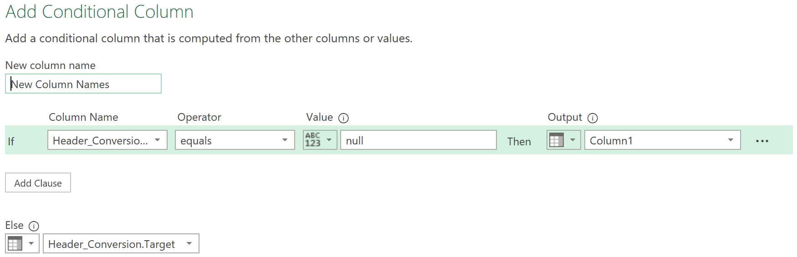

1. Move the New Column Names to the Beginning of the chart (far left)
2. Then remove Column1
3. Then go to Transform > Transpose while on the Products Sample
4. Then promote use first rows as headers
5. Now there is a problem in Append Products. Just delete the Changed Type.
6. In the Appended Product change the Size type to Text
7. In the Products Sample remove Changed Types. This will get rid of the error in the Size Column
8. Now check the Appended Products and the Size column errors should be gone.
9. Remove the Source.Name column

**Exercise 4-5 – Unpivot, Merge, Pivot**

1. This assumes you did exercise 4-4 it’s a continuation
2. Products Sample query
   1. delete some applied steps. So you are only left with Source, Navigation, and Promoted Headers.

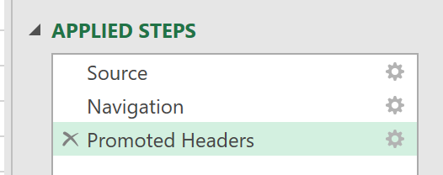

* 1. Index Column
     1. Go to Add Column > Index Column > From 0
     2. Then right click the header and click unpivot Other Columns

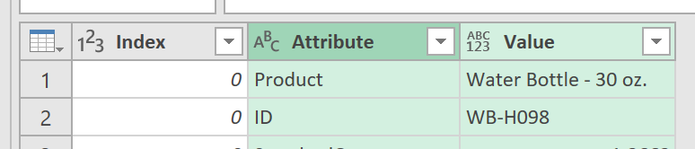

* + 1. Now you are left with Index, Attribute and Value
    2. Rename Attribute to Column1
  1. Merge Queries
     1. Now click on Products Sample > Home > Merge Queries
     2. Now in the dropdown select Header_Conversion. Then we will match the columns now. Select Column1 in Products Sample and then Source in Header_Conversion. Make sure it is a Left Outer. Then click ok.

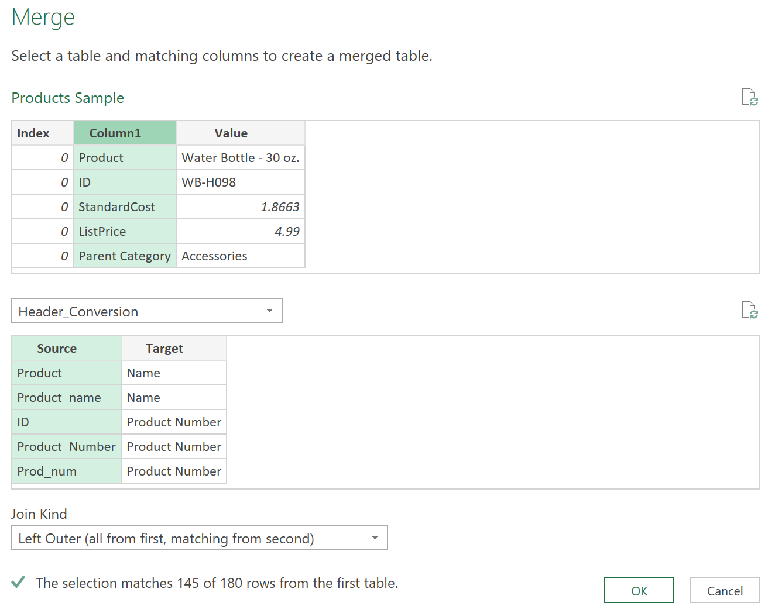

* + 1. Click on the Header_Conversion arrows and then unselect Source and only have the Target Selected.
  1. Conditional Column
     1. You will see some are still null under the Header_Conversion.Source.
     2. Click on Header_Conversion.Source then go to Add Column > Conditional column. The column Name should be New Name, Column Name: Header_Conversion. Target, Operator: equal, value: null, Output: Column1 (select from column), Else Header_Conversion.Target (Select from column)

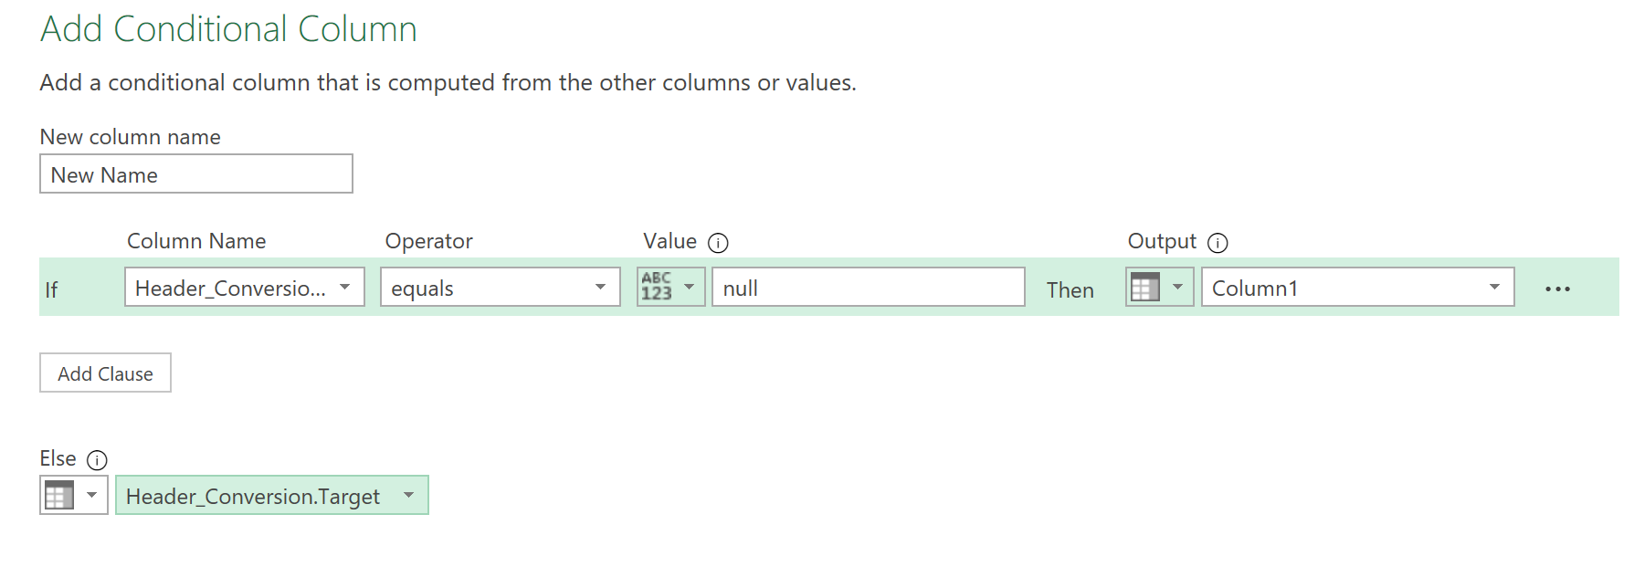

* 1. Now there should not be any nulls under the New Name Column.
  2. Then delete the Header_Conversion.Target **AND** Column1
  3. Select New Name Column (the one just created)
     1. Transform > pivot column
     2. The values column is the Value then click advanced options and in the drop down click Don’t Aggregate. Then ok.

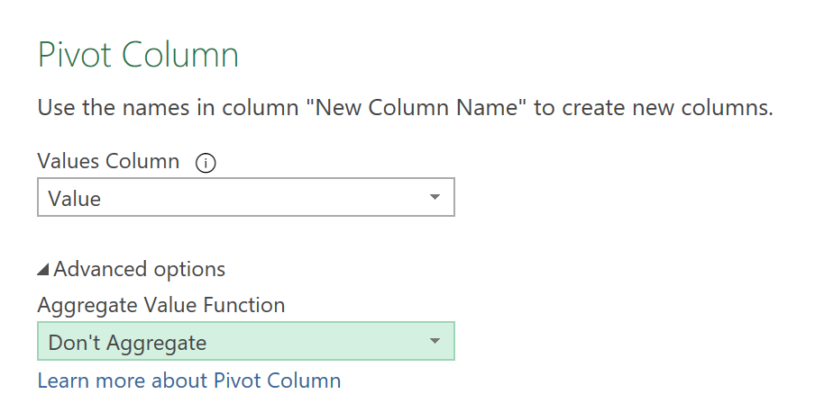

1. Appended Products there wont be a bunch of nulls.